DATA ANALYTICS ASSIGNMENT 3

Peram Vikindra Reddy 20AK1A04D1

IV B.TECH (ECE)

ANNAMACHARYA INSTITUTE OF TECHNOLOGY AND SCIENCES -TIRUPATI

**DATASET :** [**Sample - Superstore.xls**](https://docs.google.com/spreadsheets/d/1Vmsk3xJ_qp69U0AZzCpNybqX0AP4KSon/edit#gid%3D972120833)

* **Define at least two sets based on specific criteria from your dataset (e.g., high-value customers, top-performing products).**
* **Experiment with combining sets using UNION, INTERSECT, and MINUS operations.**
* **Create 2 Calculation field using any aggregate function**
* **Create any 3 visualization using quick Table Calculations**

**HIGH-VALUE CUSTOMERS BY SALES**

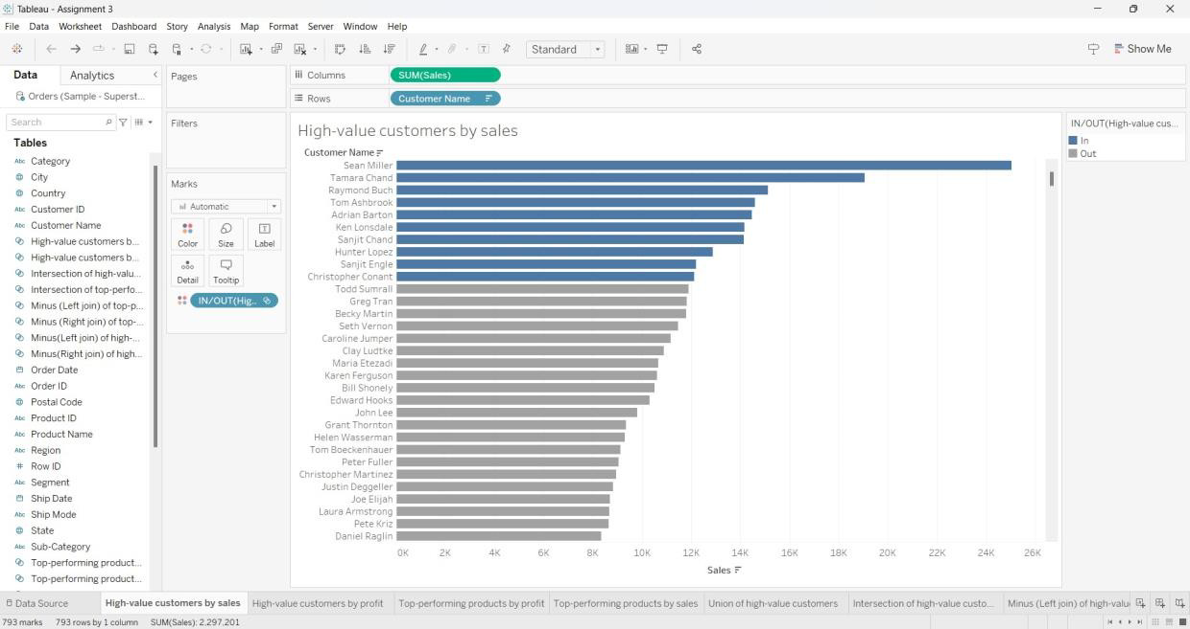

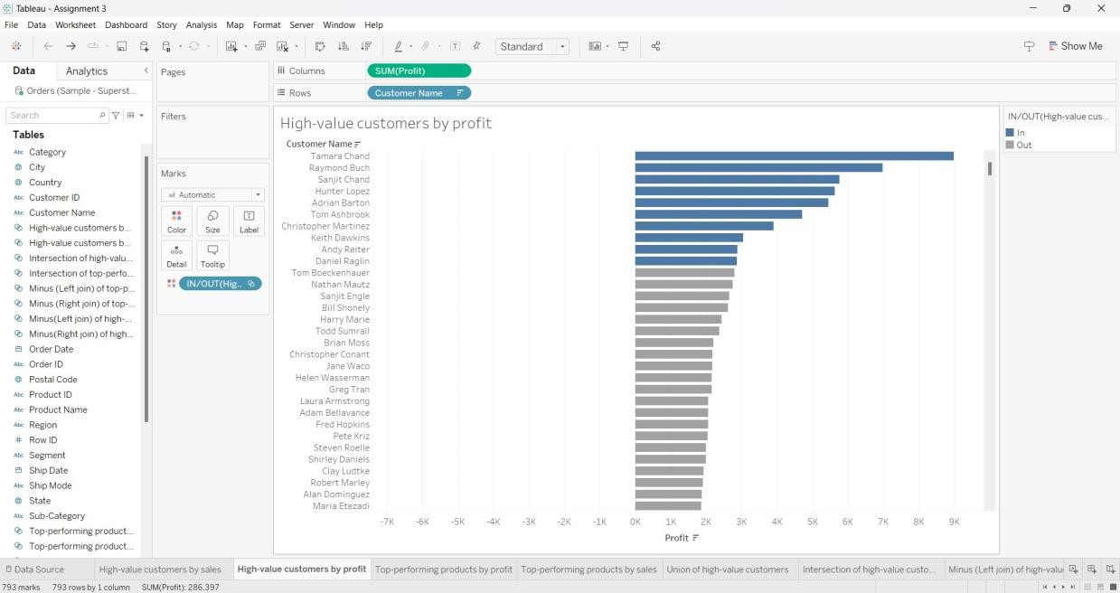

**UNION OF HIGH-VALUE CUSTOMERS**

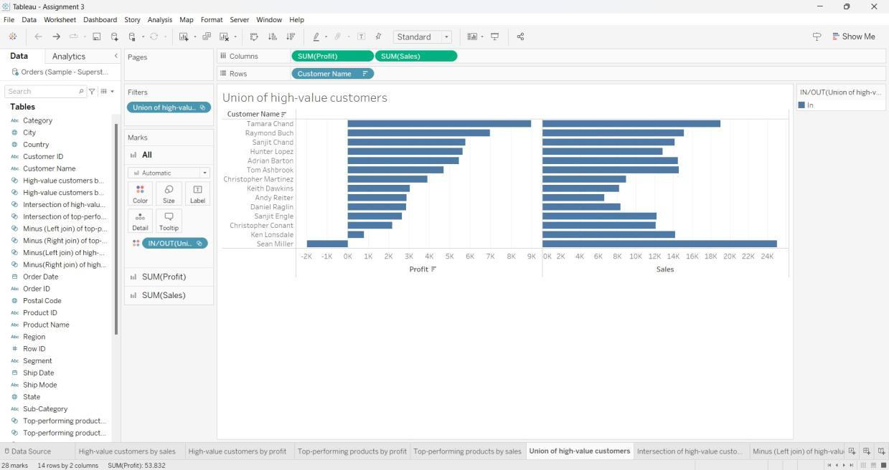

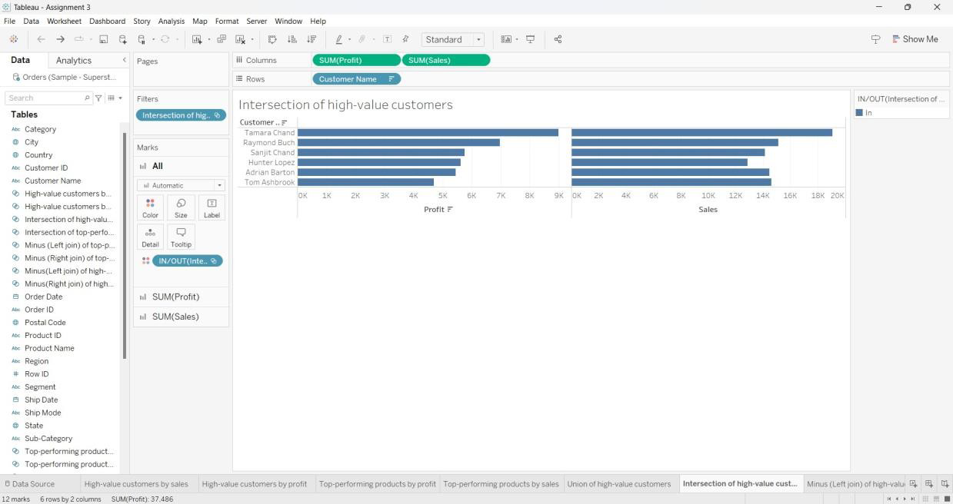

**MINUS (LEFT JOIN) OF HIGH-VALUE CUSTOMERS**

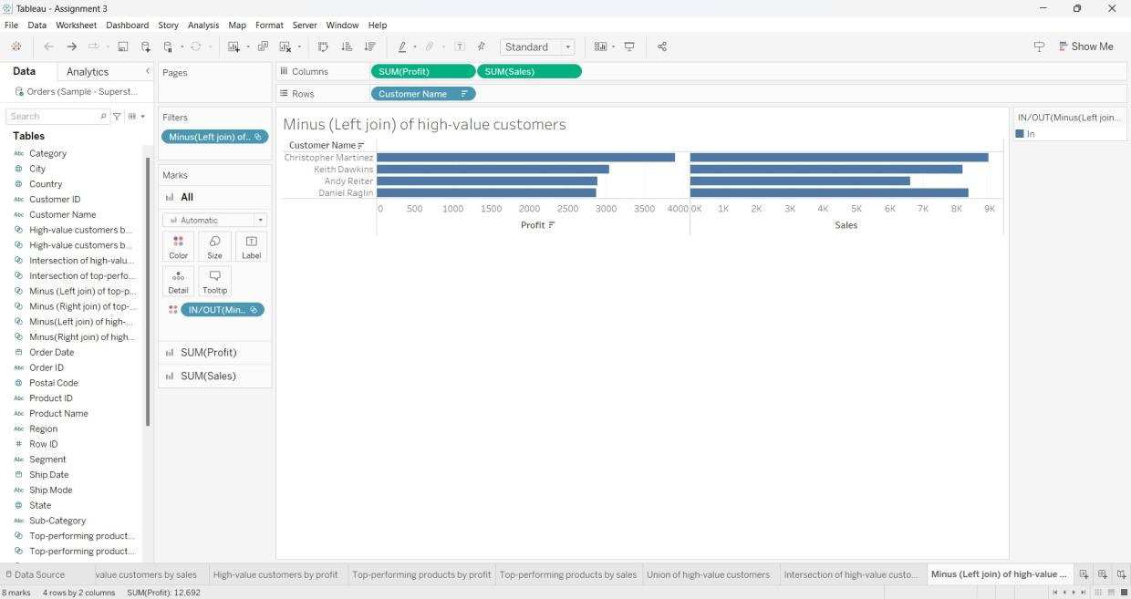

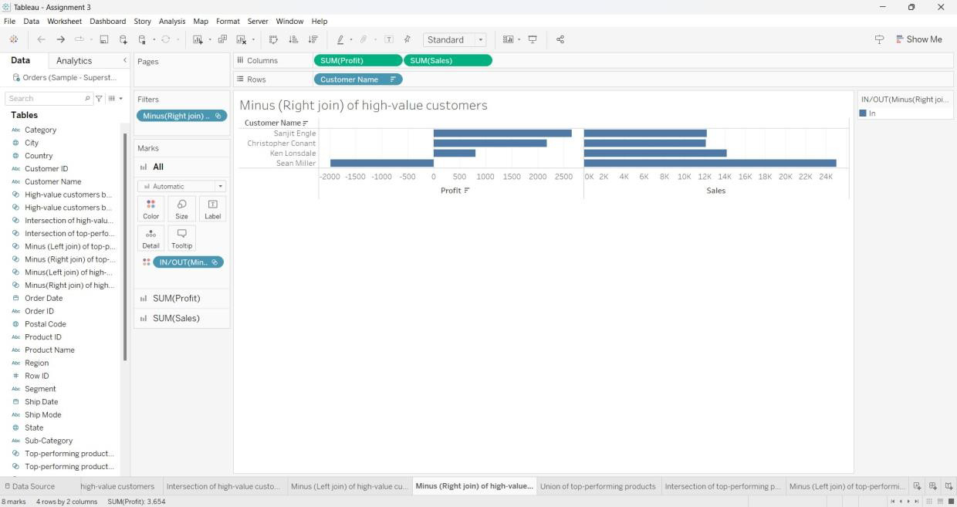

**TOP-PERFORMING PRODUCTS BY PROFIT**

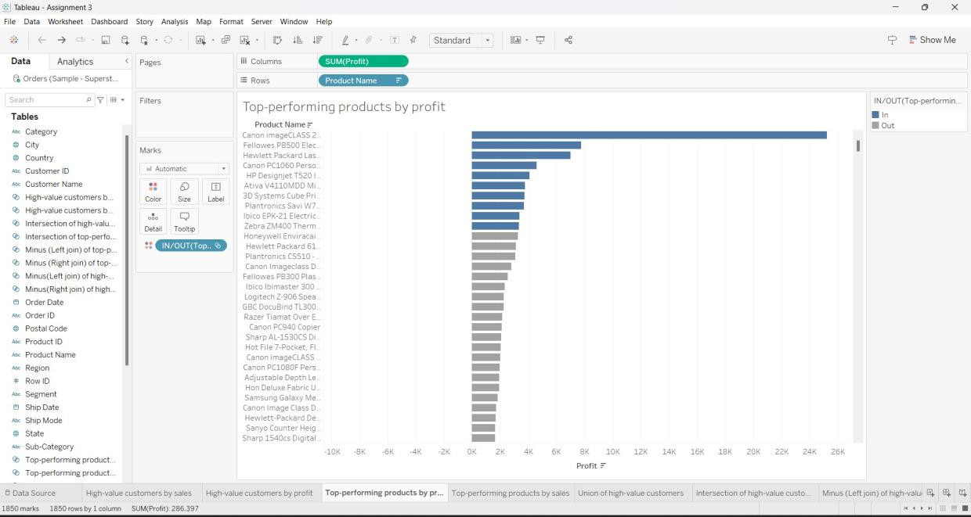

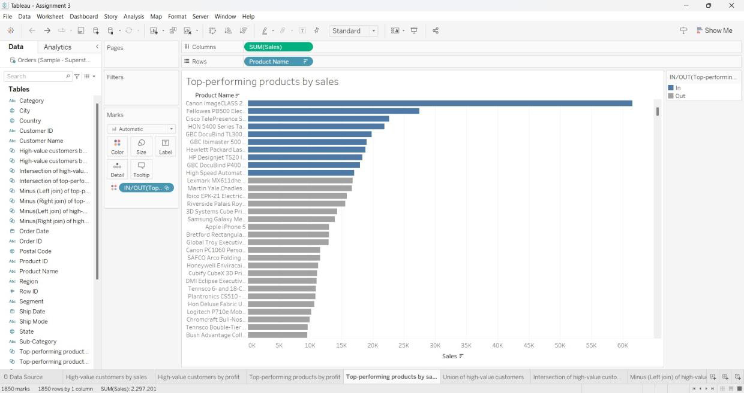

**UNION OF TOP-PERFORMING PRODUCTS**

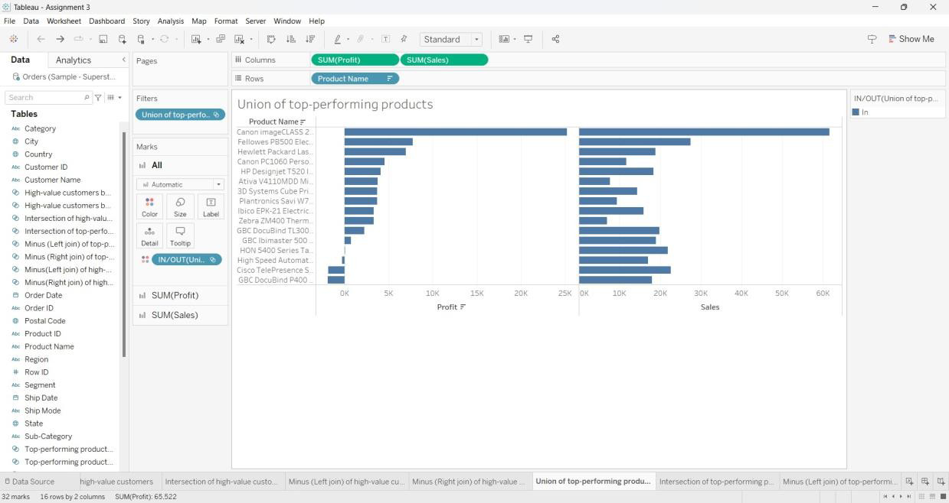

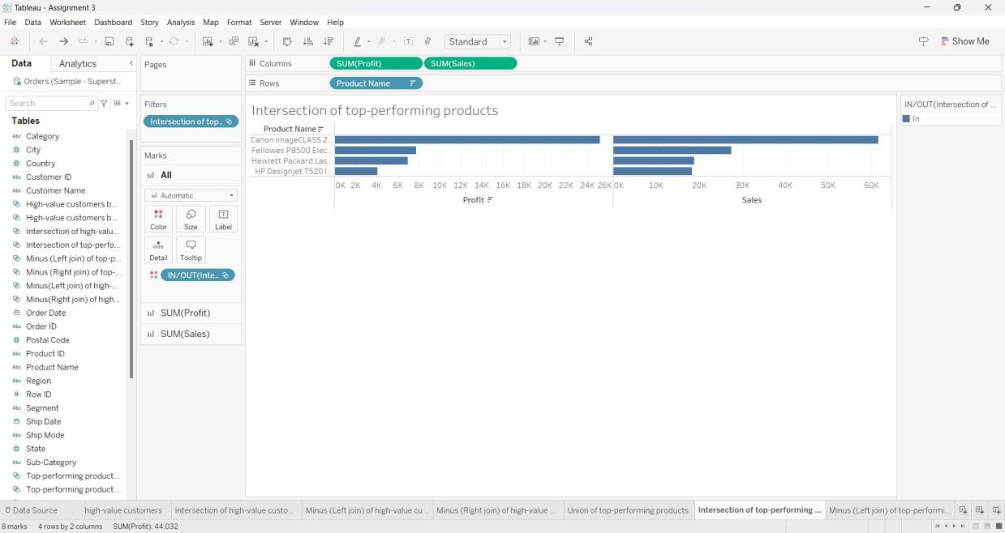

**MINUS (LEFT JOIN) OF TOP-PERFORMING PRODUCTS**

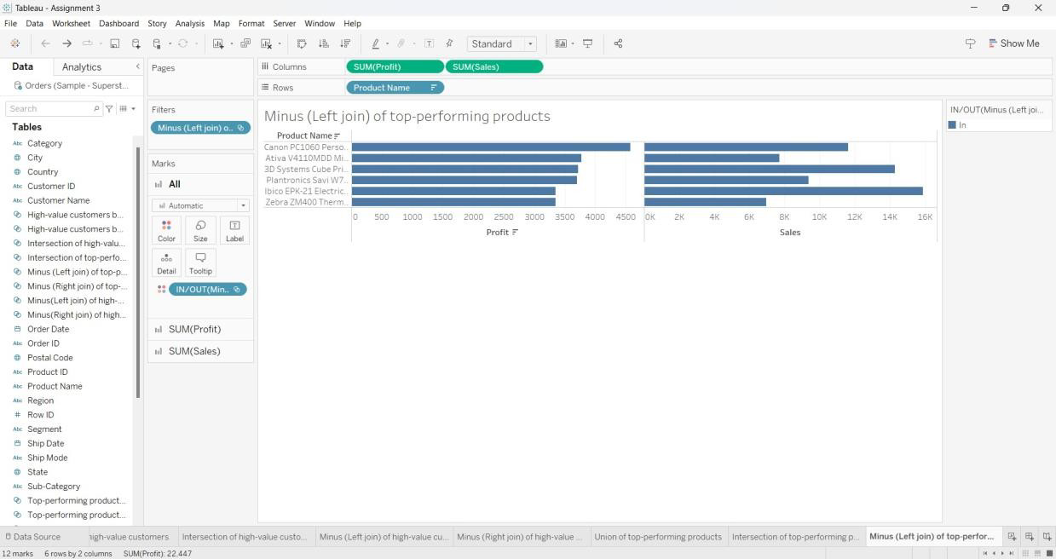

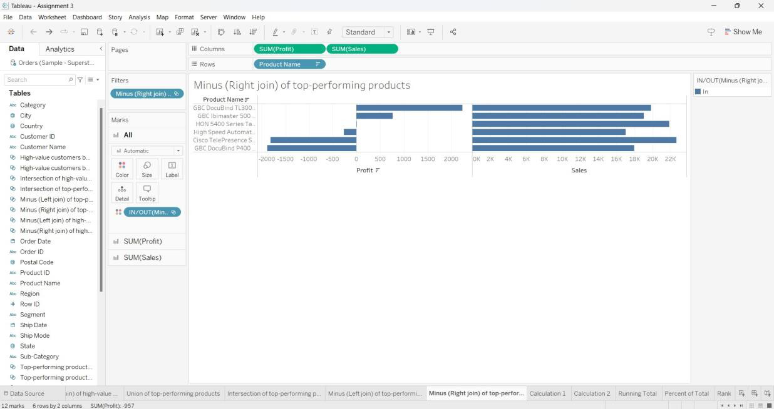

**CALCULATED FIELD - 1**

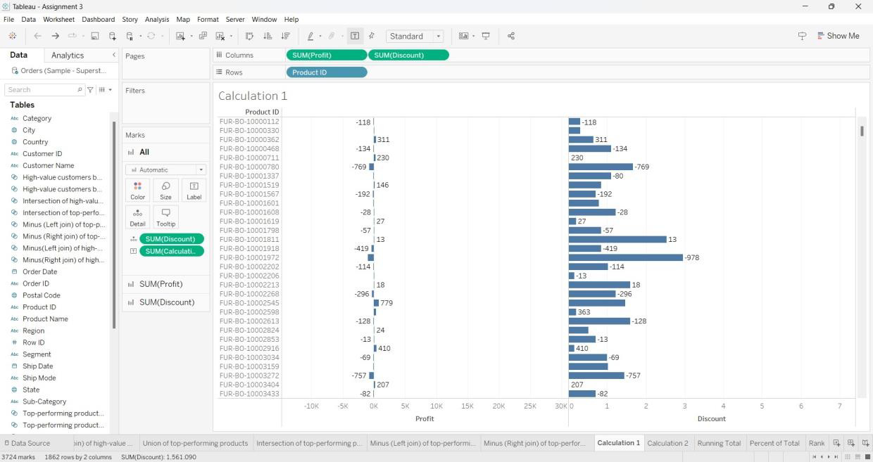

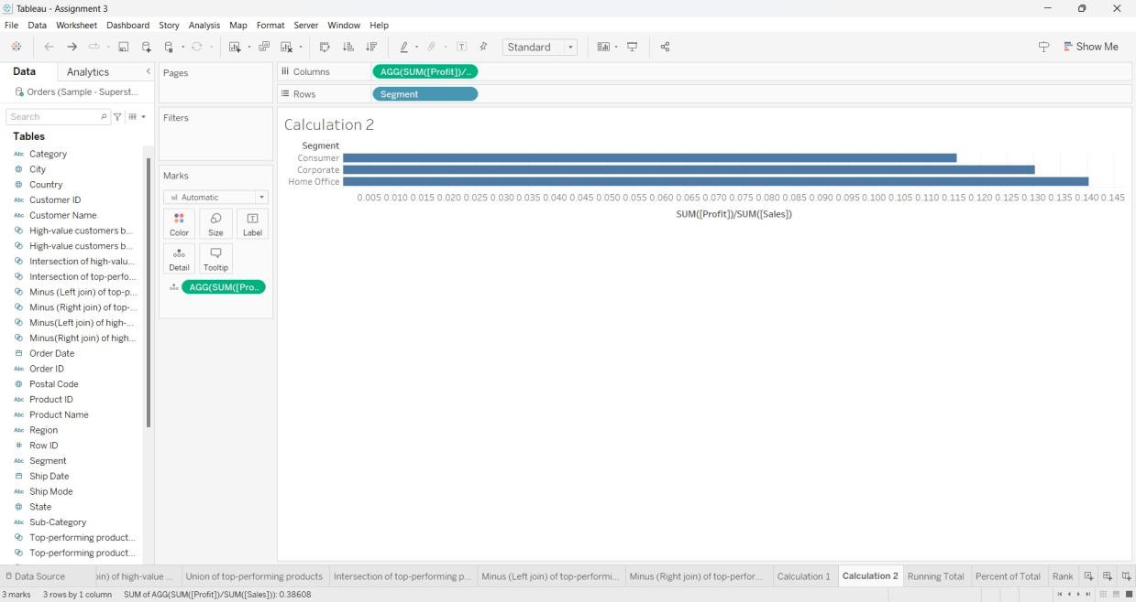

**QUICK TABLE CALCULATIONS: RUNNING TOTAL**

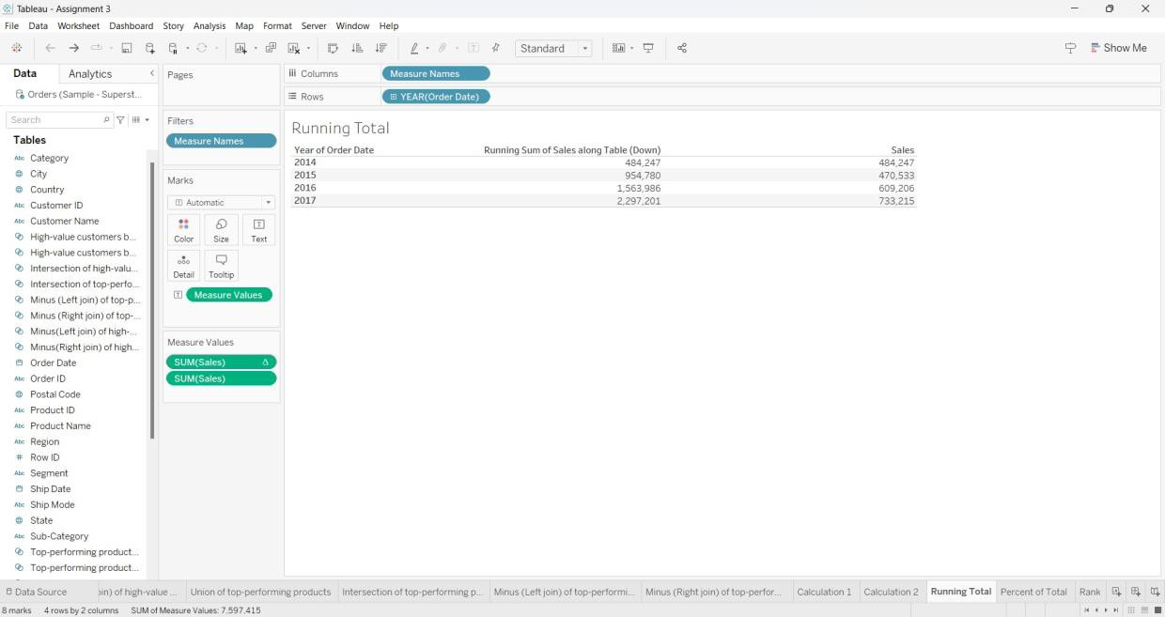

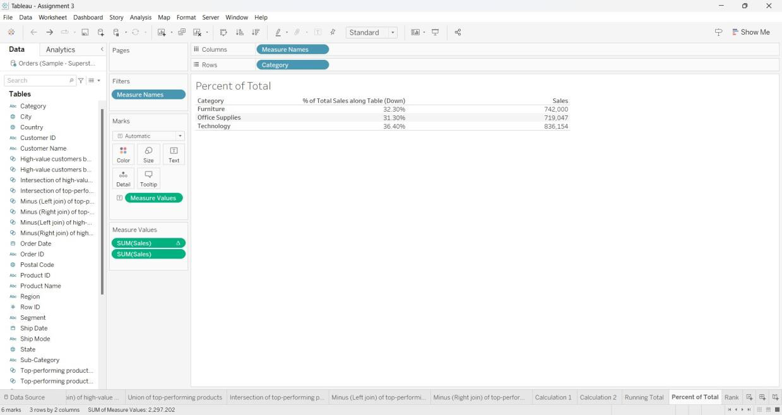

**RANK**

